*Florida International University*

*School of Computing and Information Sciences*

Software Engineering Focus

Feature Document

User Story ID <NVOS-36 General Feedback>

**Name:** Andrew Castillo

**Team Member(s):** Andrew Castillo, Bryan Bastida

**Project:** EnvoScholar 1.0

**Product Owner(s)**: Mark Finlayson

**Mentor(s)**: Masoud Sadjadi

**Instructor**: Masoud Sadjadi

**User Story Name:** General Feedback

### Description:

As a user, I want to provide general feedback, so that the user experience can be improved upon.

### Acceptance Criteria:

* User presses feedback button
* Two windows pop up collection user feedback
* Backend receives the response

**Use Case**

* Name: General Feedback
* Actor: User, webpage, Database
* Preconditions: Articles displayed on webpage as well as the Feedback button
* Description <Flow of events>:
  + User types search query and presses search
  + User navigated to display results page with database retrieved articles
  + User presses Feedback buttons
  + User Responds
  + Sends response to backend.

**Use Case Diagram**

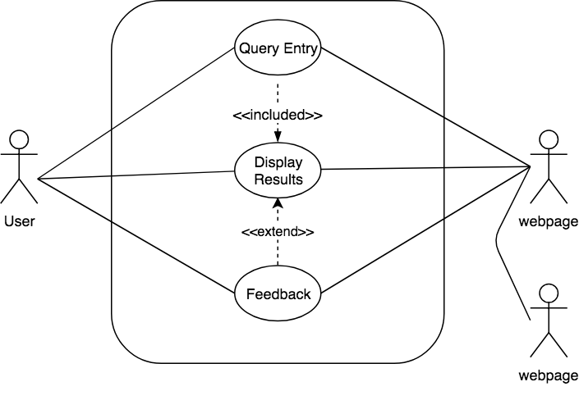

**Sequence Diagram**

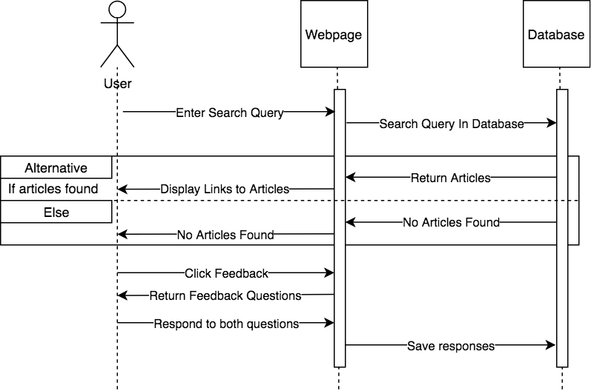

**Class Diagram**

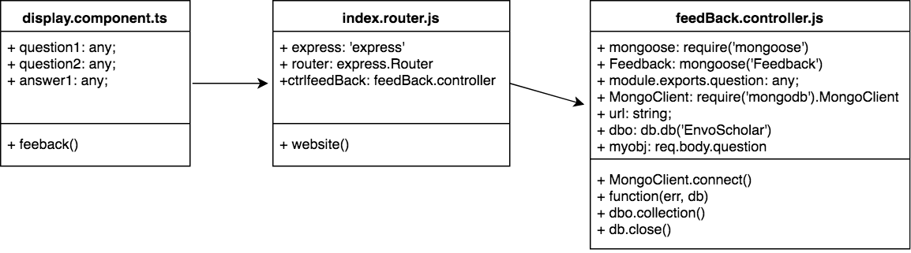

**Unit Test**

* Test case ID: NVOS-36 General Feedback
* Description/Summary of Test: Opens 2 prompts
* Pre-condition: Displayed results list given
* Expected Results: Successful storage of user feedback
* Actual Result: Successful storage of user feedback
* Status (Fail/Pass): Pass

**Visual User Guide**

